Weighted k-Nearest Neighbors (k-NN) Algorithm
In Machine Learning, the k-Nearest Neighbors (k-NN) algorithm is a simple yet powerful tool used for classification and regression tasks. It belongs to the family of non-parametric algorithms, which means it doesn’t build an explicit model but instead makes predictions based on the similarity of data points. We’ll explore the concept of weighted k-NN, an extension of the basic k-NN algorithm.
k-NN:
Imagine you have a dataset with various data points, each associated with a class or value. When you want to predict the class or value of a new data point, k-NN looks at the k nearest data points (nearest neighbors) in the training dataset to determine the prediction.
Here’s a step-by-step process to do that:
1. Calculate the distance between the new data point and all data points in the training dataset. Common distance metrics include Euclidean distance and Manhattan distance.
2. Select the k-nearest data points with the smallest distances to the new data point.
3. For classification tasks, count the occurrences of each class among the k-nearest neighbors and choose the class with the highest count(mode) as the predicted class.
4. For regression tasks, take the average (mean) of the values associated with the k-nearest neighbors as the predicted value.
This basic k-NN algorithm works quite well in many cases, but it treats all neighbors equally

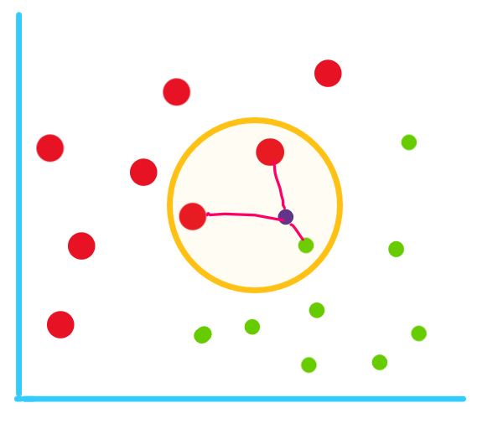
weighted k-NN introduces the concept of assigning different weights to neighbors based on their proximity to the query point, which can lead to improved performance.
Weighted k-NN not only considers the nearest neighbors but also how close or far away they are. In this approach, instead of treating all k-nearest neighbors equally, we assign different weights to them based on their distance from the query point.
Steps involved in weighted k-NN:
1. Calculate the distance between the new data point and all data points in the training dataset, just like in basic k-NN.
2. Select the k-nearest data points like in k-NN.
3. Assign a weight to each of the k-nearest neighbors inversely proportional to their distance from the query point. In simpler terms, closer neighbors get higher weights, while farther neighbors get lower weights.
4. For classification tasks, when determining the predicted class, the contributions of neighbors are scaled by their weights. Closer neighbors have a stronger influence on the prediction.
5. For regression tasks, the values associated with neighbors are multiplied by their weights before averaging, giving more importance to closer neighbors in the prediction.
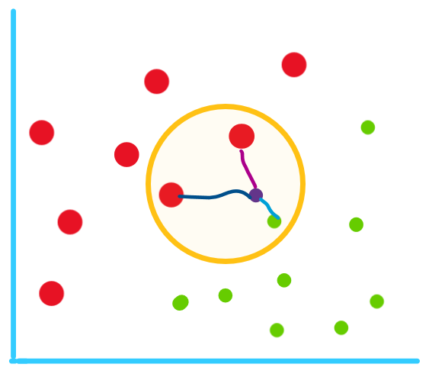
In weighted k-NN, as we consider the weights of the points the predicted value will be ‘green’ as the point has higher weight compared to the other points.

he intuition behind weighted kNN, is to give more weight to the points which are nearby and less weight to the points which are farther away. Any function can be used as a kernel function for the weighted knn classifier whose value decreases as the distance increases. The simple function which is used is the inverse distance function. Algorithm:
- Let L = { ( x_{i} , y_{i} ) , i = 1, . . . ,n } be a training set of observations x_{i} with given class y_{i} and let x be a new observation(query point), whose class label y has to be predicted.
- Compute d(x_{i}, x) for i = 1, . . . ,n , the distance between the query point and every other point in the training set.
- Select D' ⊆ D, the set of k nearest training data points to the query points
- Predict the class of the query point, using distance-weighted voting. The v represents the class labels. Use the following formula
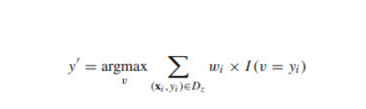
Advantages of weighted k-NN algorithm:
1. Improved Accuracy: By considering the proximity of neighbors, weighted k-NN often makes more accurate predictions, especially when the dataset has varying densities.
2. Adaptability: Weighted k-NN adapts to the local structure of the data, making it more robust to outliers and noisy data points.
3. Flexibility: You can choose different weighting schemes, such as linear or exponential, depending on the problem and dataset.
4. Reduced Bias: It reduces bias towards the majority class in imbalanced datasets by giving minority class instances more weight if they are closer to the query point.

Example

Problem Statement
Classify Test Point X = 5 using:
- K = 5
- Normal KNN (majority voting)
- Weighted KNN (weight = 1 / distance)
- Training Data
Point | X | Class
A | 1 | Class 0
B | 2 | Class 0
C | 3 | Class 0
D | 6 | Class 1
E | 7 | Class 1

Step 1: Compute Distances
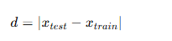
Point | Class | Distance
A | 0 | 4
B | 0 | 3
C | 0 | 2
D | 1 | 1
E | 1 | 2

NORMAL KNN (Majority Voting)

Step 2: Count Class Labels (K = 5)
- Class 0 → A, B, C = 3 votes
- Class 1 → D, E = 2 votes

WEIGHTED KNN

Step 3: Compute Weights
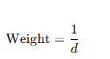
Point | Class | Distance | Weight
A | 0 | 4 | 0.25
B | 0 | 3 | 0.33
C | 0 | 2 | 0.50
D | 1 | 1 | 1.00
E | 1 | 2 | 0.50

Step 4: Sum Weights per Class

Class 0:
0.25+0.33+0.50=1.080.25 + 0.33 + 0.50 = 1.080.25+0.33+0.50=1.08

Class 1:
1.00+0.50=1.501.00 + 0.50 = 1.501.00+0.50=1.50
WEIGHTED KNN Prediction=Class 1
Normal KNN Prediction=Class 0

In normal KNN, all neighbors contribute equally, so the majority class is selected.
In weighted KNN, nearer neighbors receive higher weights, which can change the final class label when closer points belong to a different class.
REGRESSION PROBLEM

Predict Y value for X = 5 using:
- K = 5
- Normal KNN Regression
- Weighted KNN Regression
Given Data Set
Point | X | Y
A | 1 | 10
B | 2 | 12
C | 3 | 14
D | 6 | 40
E | 7 | 42

Point | X | Y |  | Distance from X=5
A | 1 | 10 | 4
B | 2 | 12 | 3
C | 3 | 14 | 2
D | 6 | 40 | 1
E | 7 | 42 | 2

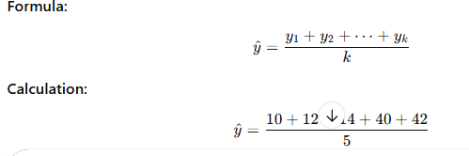
23.6

Weighted knn
Point | Y | Distance | Weight
A | 10 | 4 | 0.25
B | 12 | 3 | 0.33
C | 14 | 2 | 0.50
D | 40 | 1 | 1.00
E | 42 | 2 | 0.50

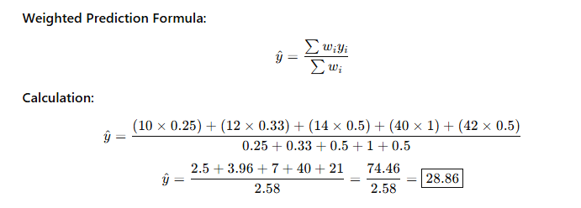
Method | Predicted Y
Normal KNN Regression | 23.6
Weighted KNN Regression | 28.86

